**DEPARTMENT OF INFORMATION TECHNOLOGY**

**Course Name and Code:** Data Structures Lab **(**ITL302)

**Semester:** III (SYIT)

**Academic Year:** 2024-25 (Odd Semester)

**Experiment No. 04**

**Aim:** Implementation of Double-ended Queue using Array for real-world application.

**Code:**

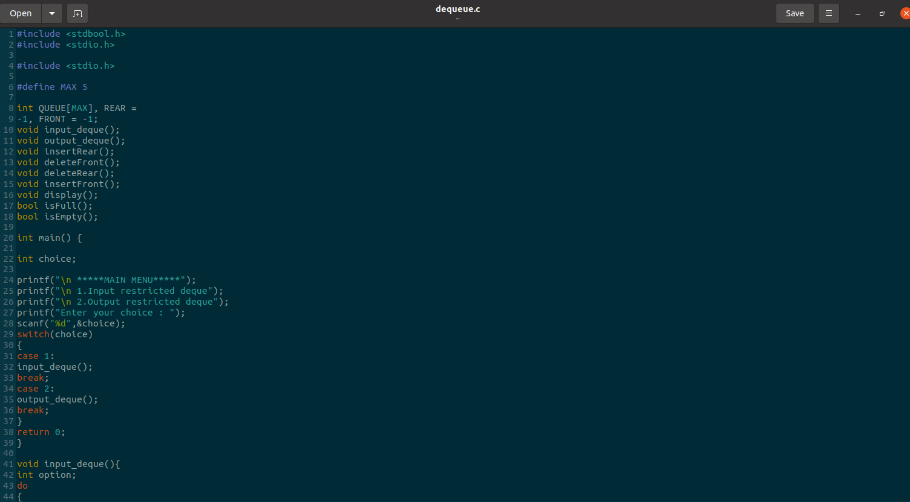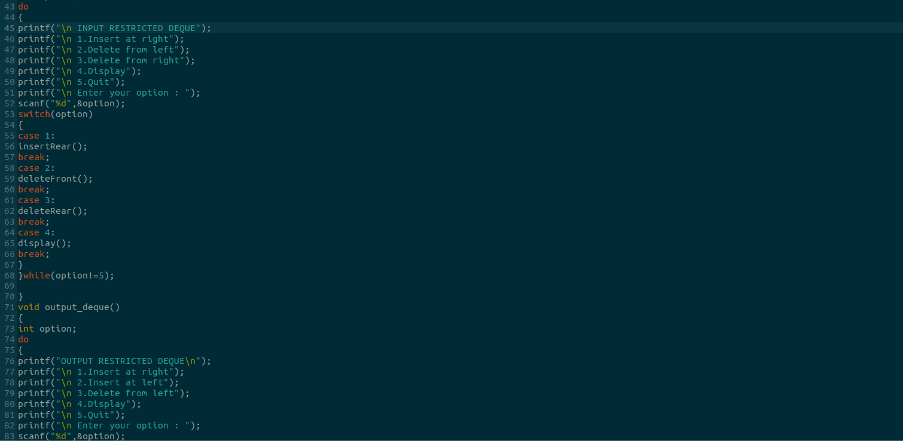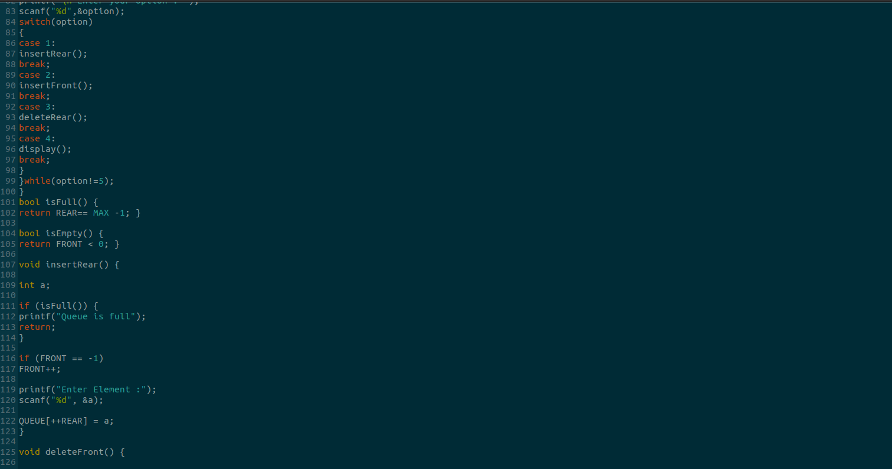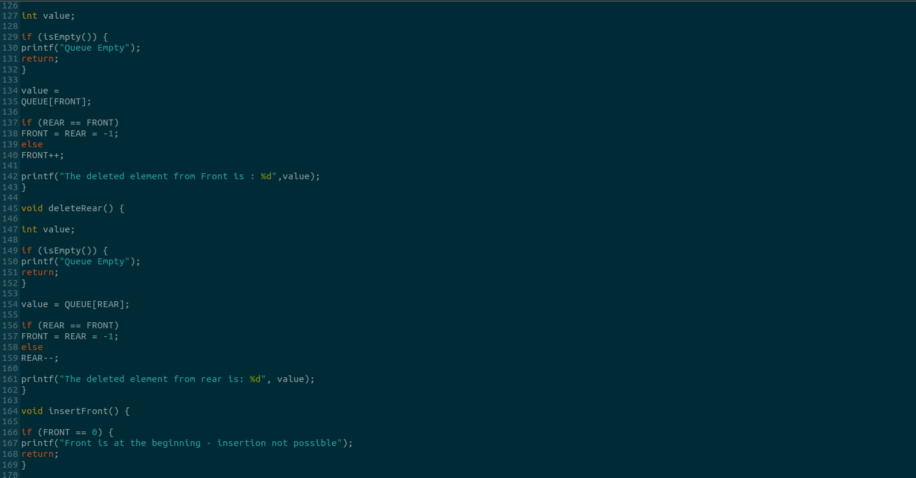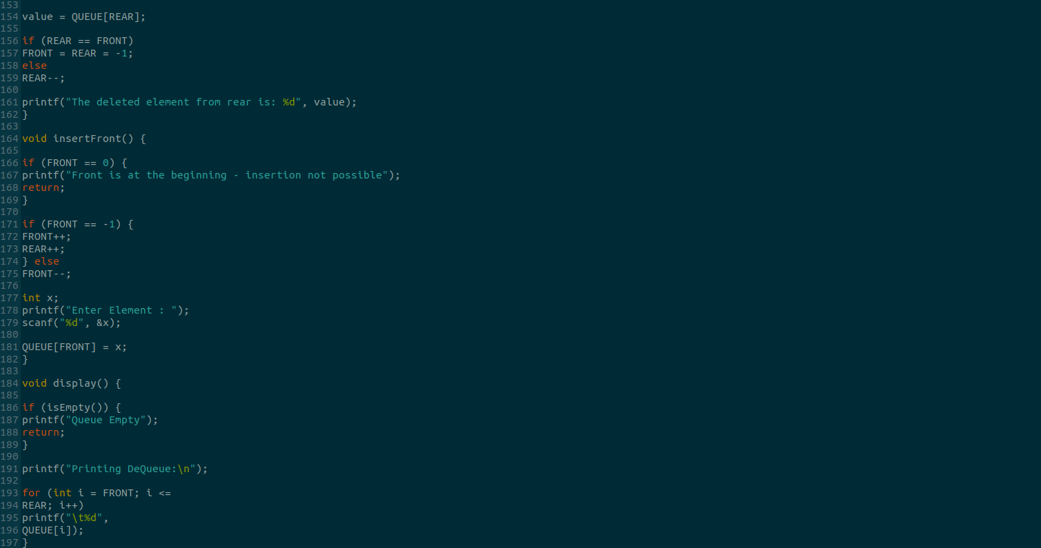

**Output:**

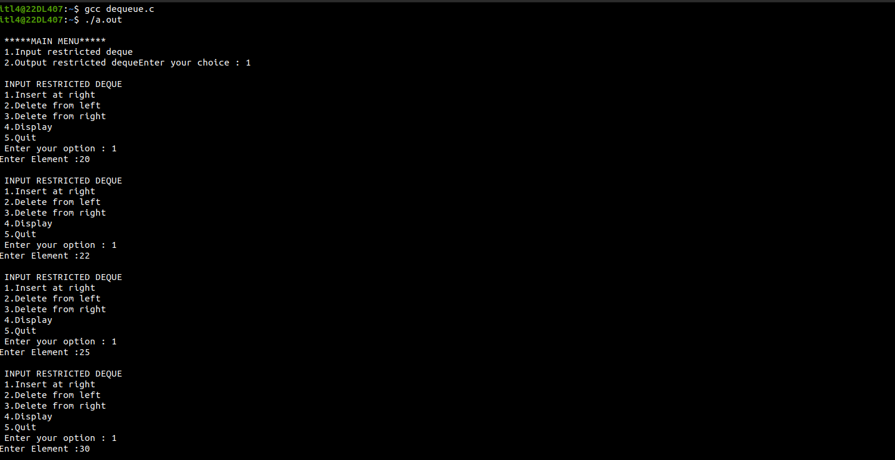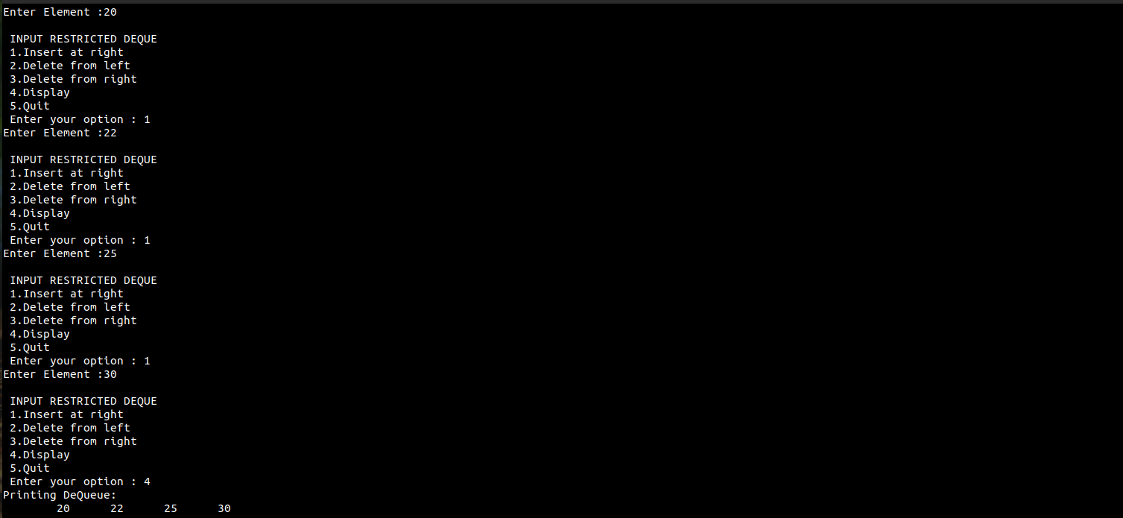

**Submitter Details:-**

**Name:** Abhinav.S.Dasari

**Roll No:** 16

**Div/Batch :** A/ S-2